**Accomplishments**

**Digicel Scholarship Recipient (Fall 2018)**

**Photos: Digicel Jamaica awards 13 tertiary scholarships**

**LOOP NEWS CREATED: 27 NOVEMBER 2018**[OUR ENDZ](http://www.loopjamaica.com/category/loopjamaica-our-endz)

Digicel Jamaica CEO Justin Morin (centre) and two of the company's scholarship recipients were all smiles following the awards ceremony on Tuesday. (Photo: Marlon Reid)

Digicel Jamaica brought an early Christmas gift of scholarships to 13 tertiary students at an awards ceremony held at its downtown Kingston office on Tuesday.

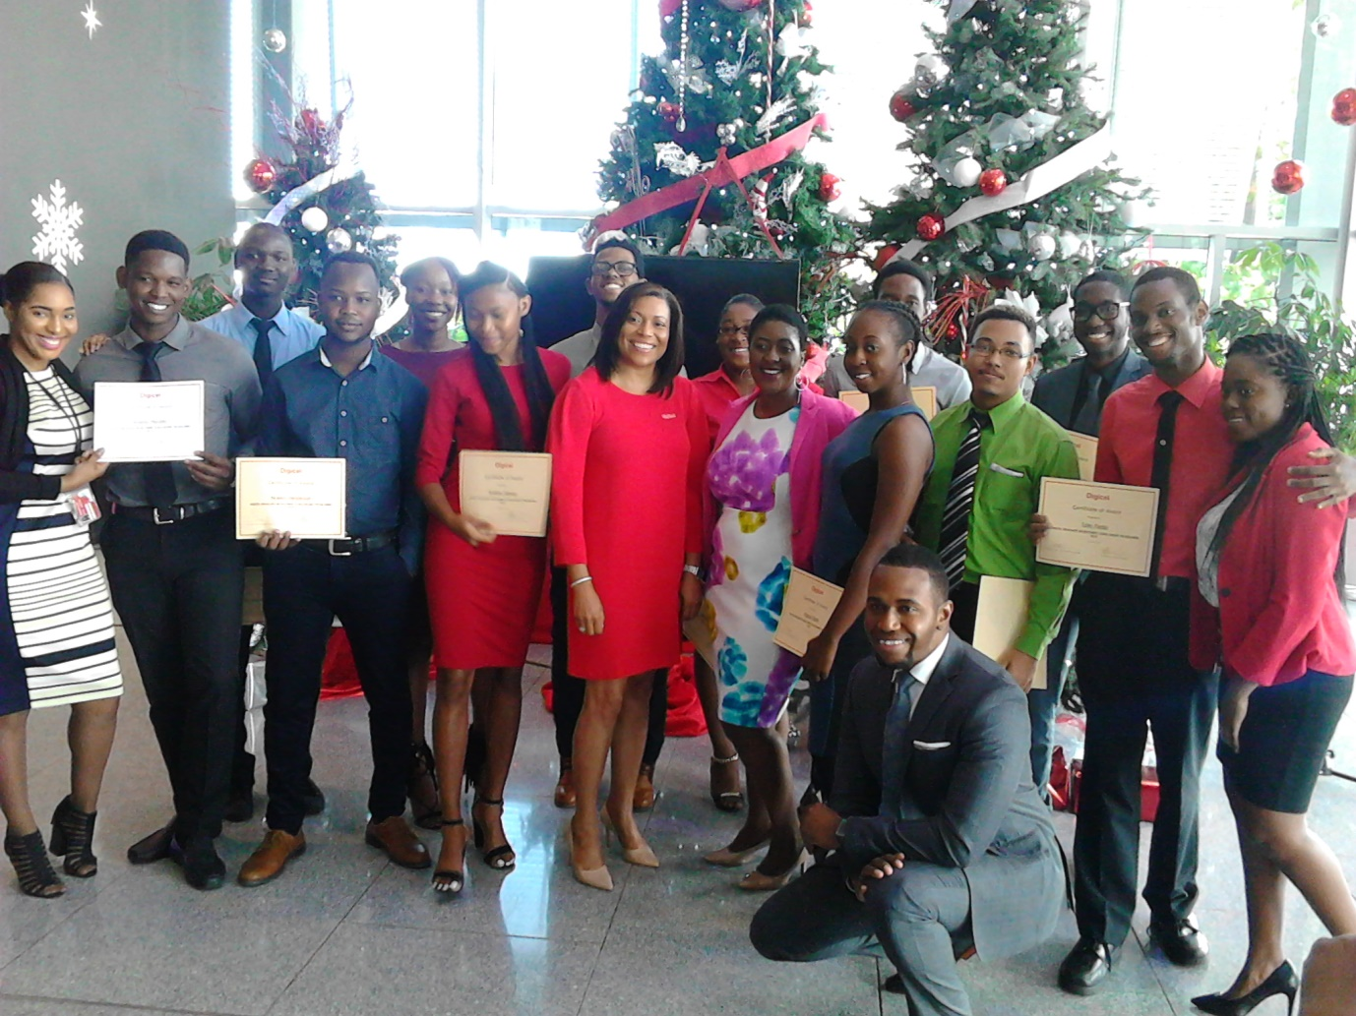

Each recipient received a tablet and $145,000 to help with their studies.

Four students from the University of Technology (UTECH) were awarded, Edna Manley saw three of its students awarded, while Northern Caribbean University (NCU), university of the commonwealth Caribbean (UCC) and university of the west indies (UWI) each had two scholarship recipients.

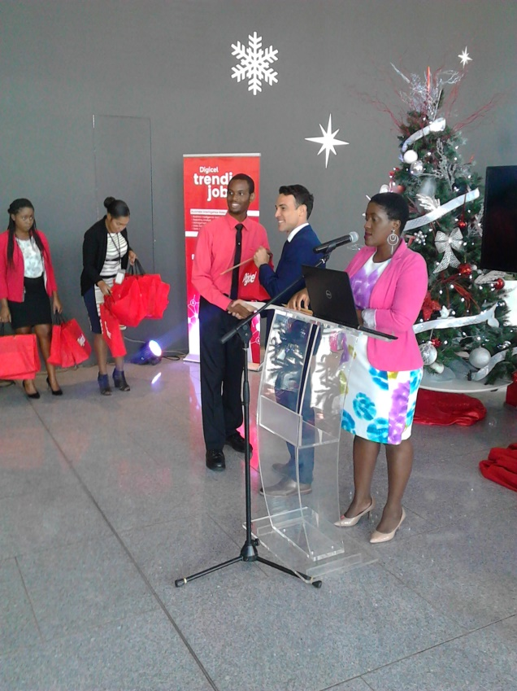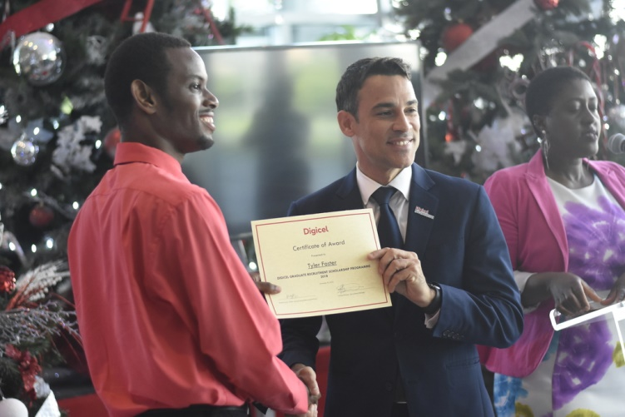

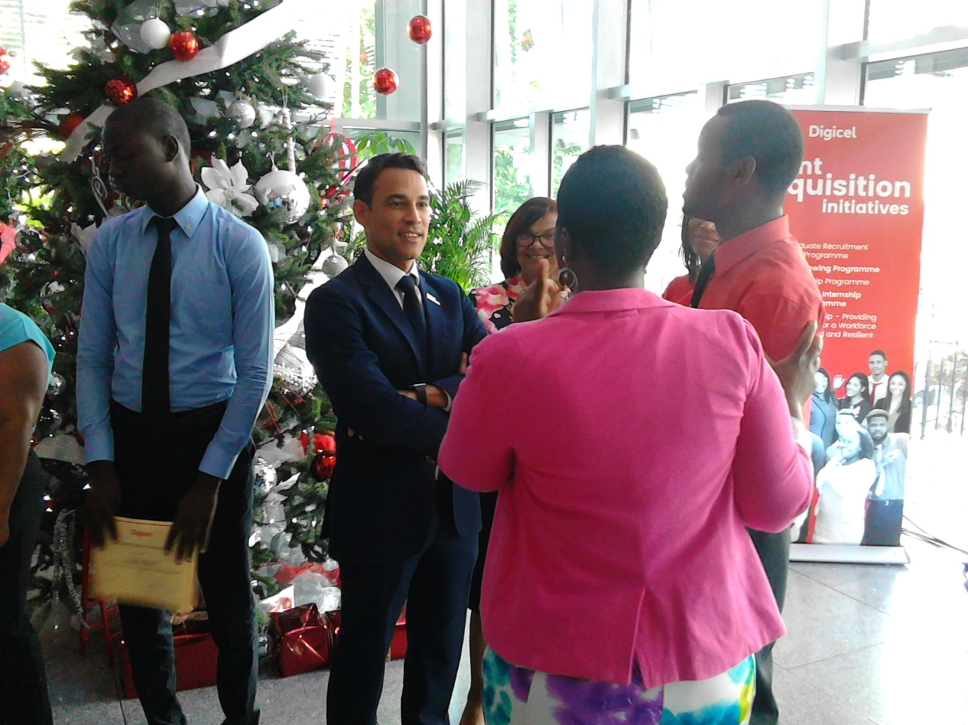

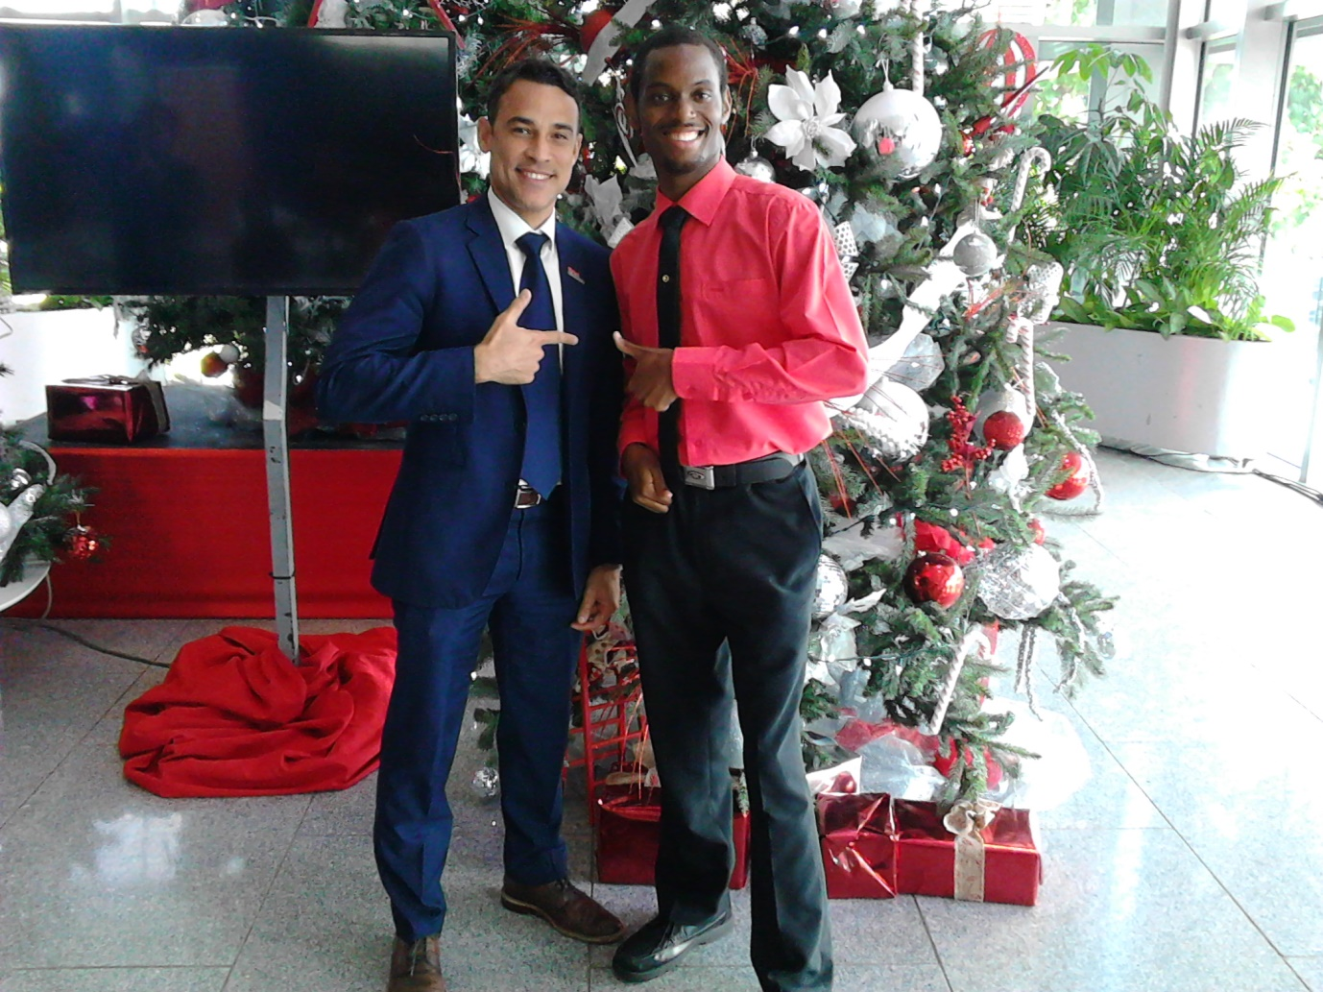

**I was named “Most Outstanding Student with the Highest GPA” three semesters in a row in the Computer Information Science Department up until my time graduation.**

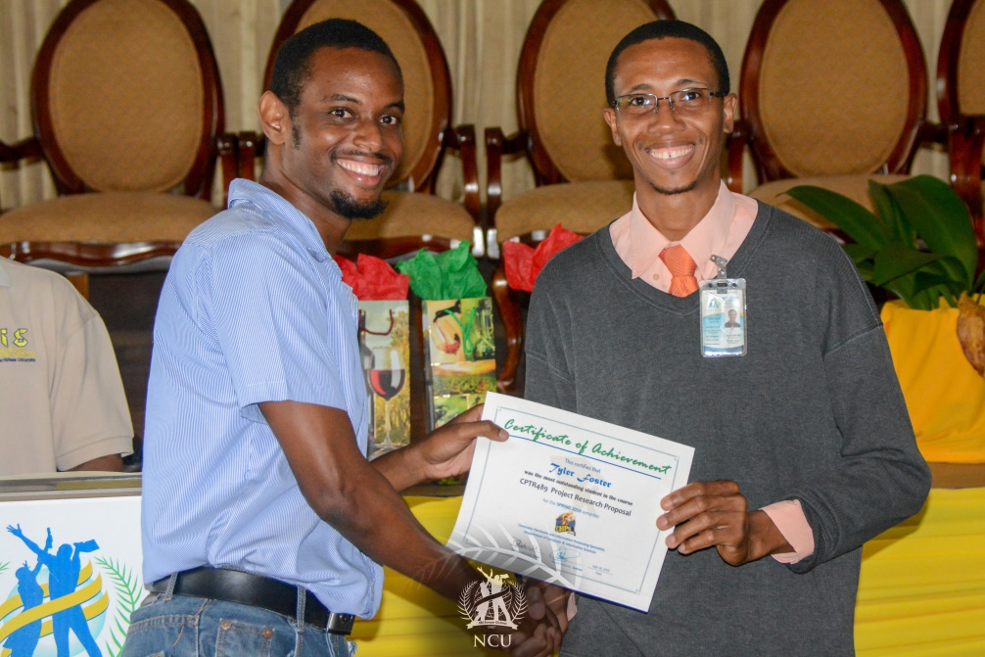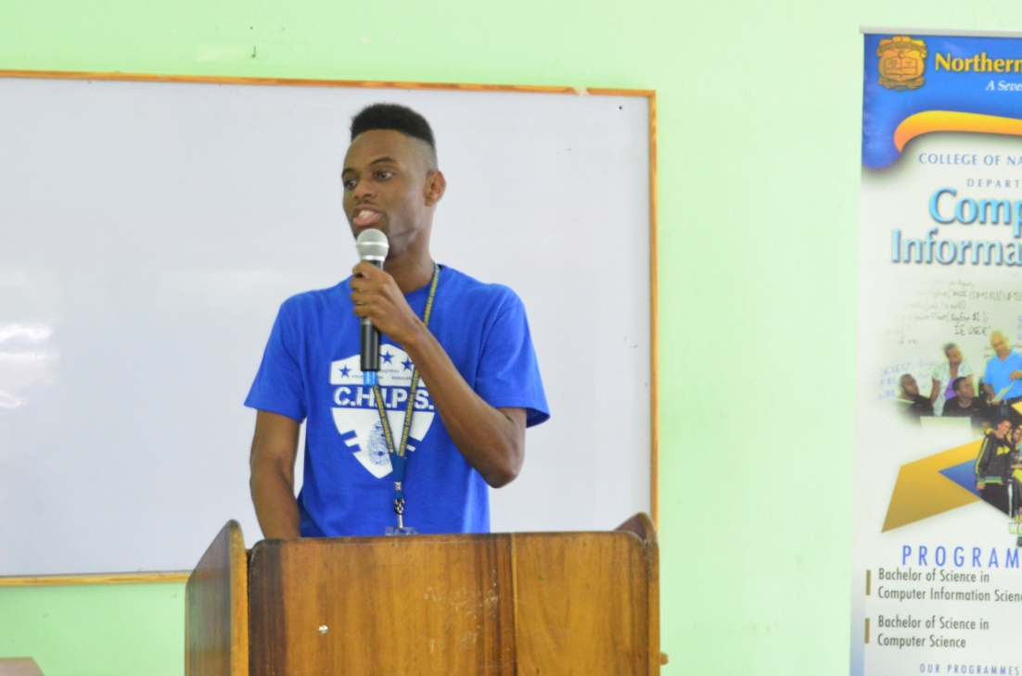

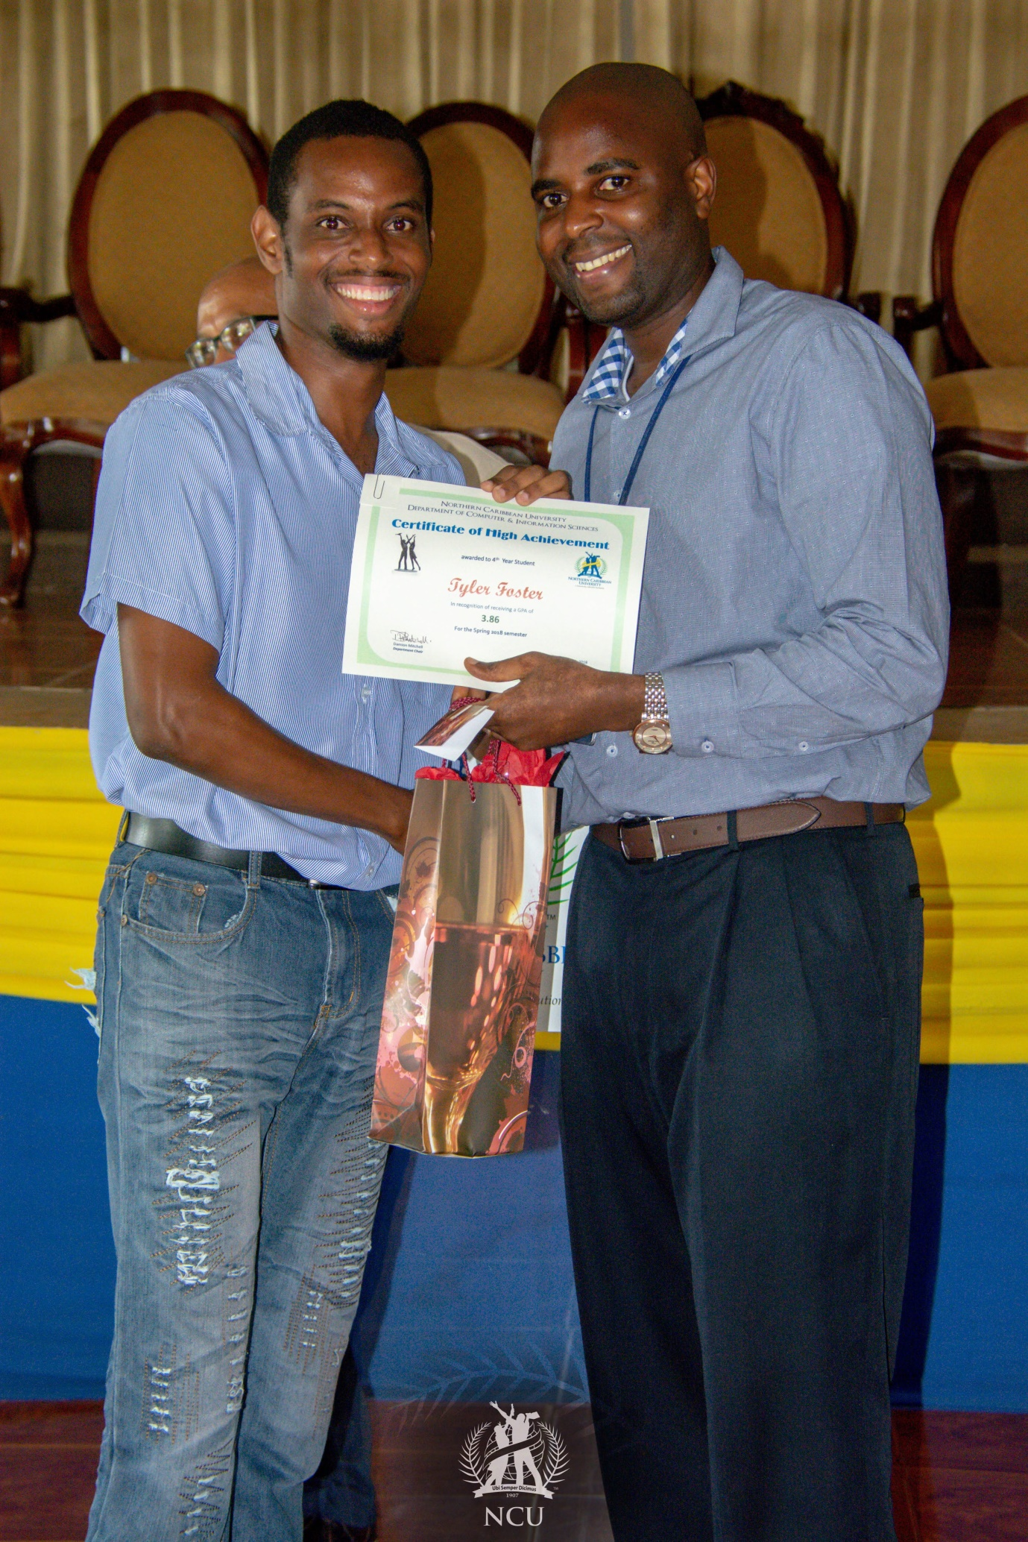



**Innovation powerhouse Northern Caribbean University (NCU) has retained first place in the National Science and Technology Competition hosted by the Scientific Research Council (SRC).**

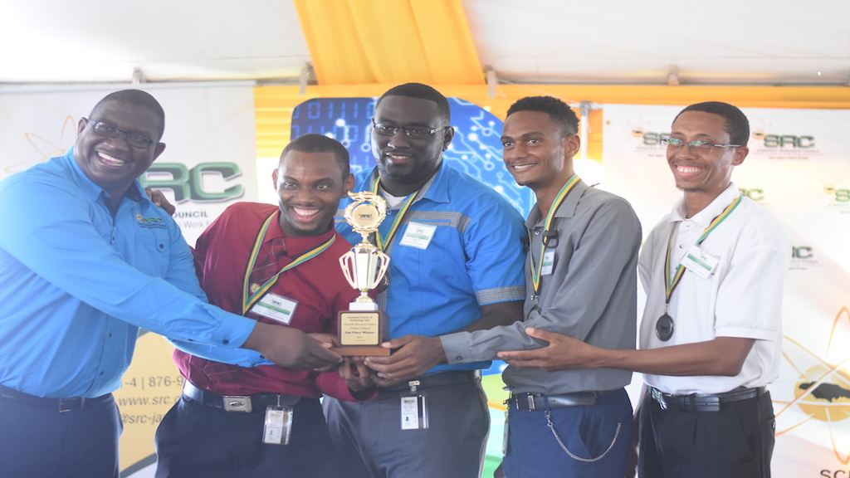

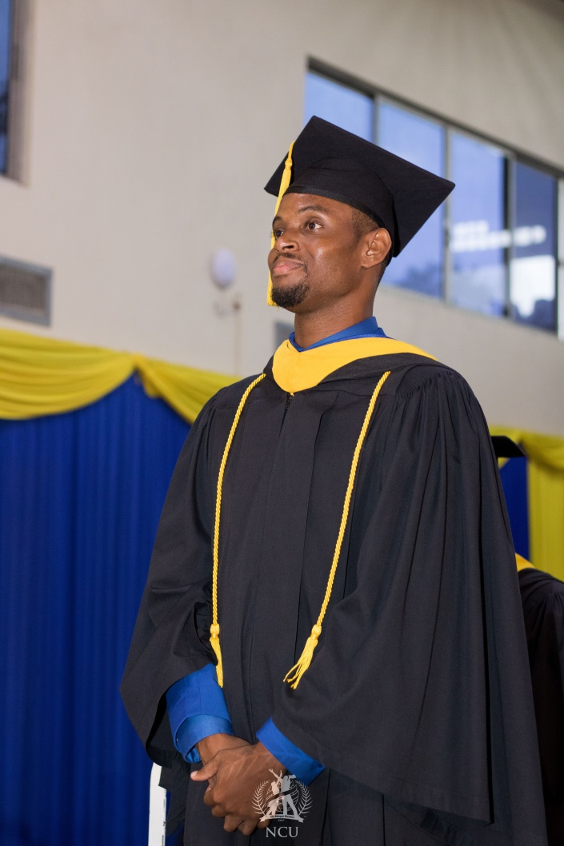**Last but not the least was graduating at the top of my class in the Computer Information Science Department.**

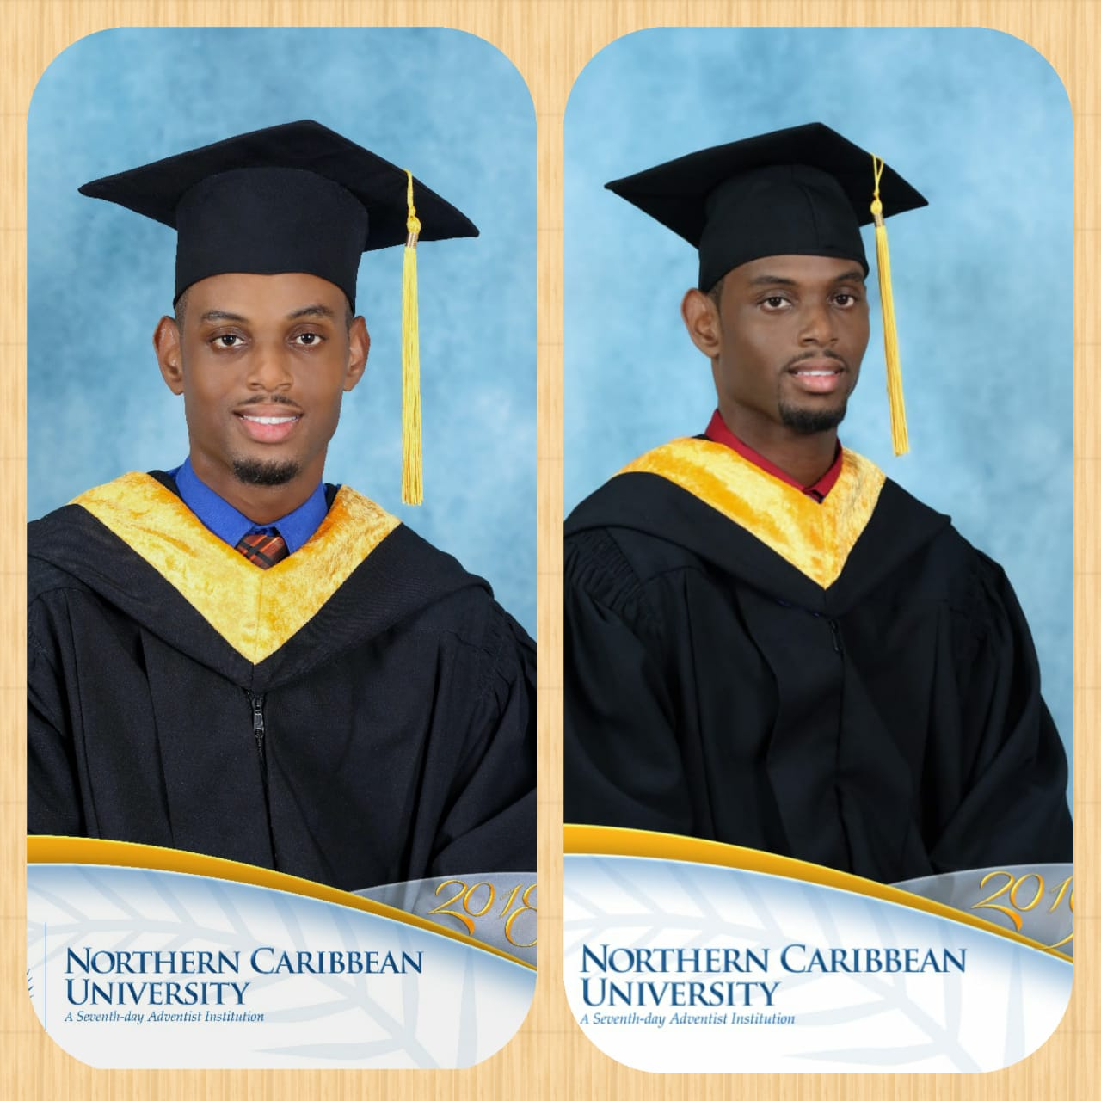

**Associates Degree in Information Technology 2018**

**Bachelors Degree in Computer Information Systems 2019**

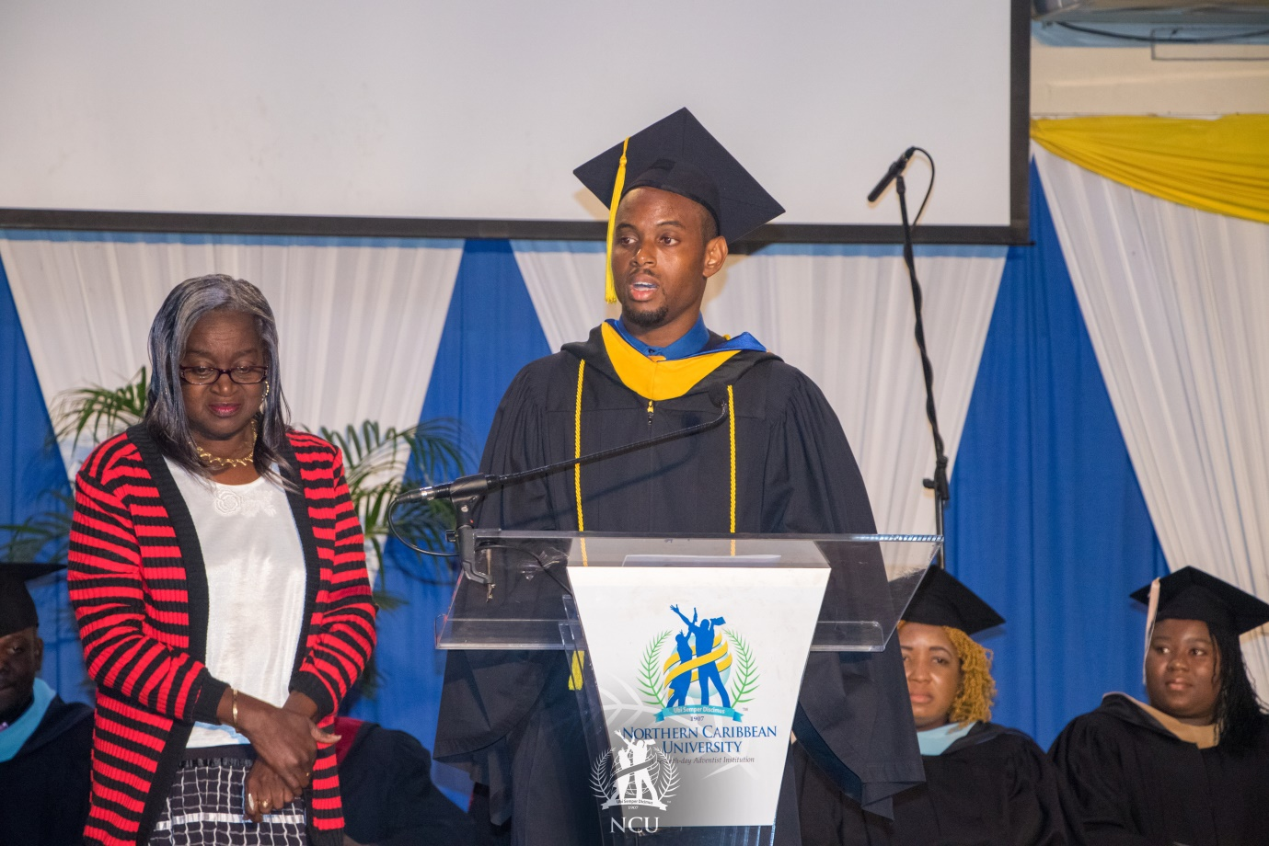

**Public Relations Officer for the Executive Graduating Class Committee (August 2019)**

Of all the accomplishments the one for being selected for the post of Public Relations Officer for the centennial anniversary of the Northern Caribbean University graduating class. And if it was not sweet enough I had my mother by my side through it all.